Contents

1. Viewing Existing Rates 2
2. Viewing Scale Points 2
3. Adding a new Pay Scale (Grade) 3
3.1. Setting up the Pay Scale 3
3.2. Setting up the Scale Points 4
3.3. Setting up the Rates (Annual salary) 5
3.4. Assign Pension to Grade 6
3.5. Set up PR and GL output rules 8
4. Editing existing Pay Scales Rates 9
4.1. Updating the rates 9
4.2. Removing existing pay scale points 10
4.3. Adding a new pay scale point to an existing grade 10
5. Removing an existing Grade 11

Document Version Control
Change History/Review Details
Date | Version | Review by | Summary of Change
 | 1.0
Nov/Dec20 | 2.0 | HC | Reviewed following the implementation of V28. Minor changes only
Jun 2021 | 3.0 | HC | Updated to reflect the move to Portal

Knowledge Article: Grades and Rates

Reports

A number of reports include or specifically exclude grade details so you will need to check which reports may need to be updated.

Examples include:
PERDEP01 Staff in Post
PERDEP20 Monthly Changes
PERDEP21 Monthly Data Input check

Other related documents

Further documentation can be found under P:\PROJECTS\HRIS Programme\12. Support\Reference Data\Grades & Rates\Documentation

Viewing Existing Rates

Core|Portal > Payroll Dashboard > Pay Rates > View Position Rates

Enter/select the Position Code you wish to view. The current values will be displayed:

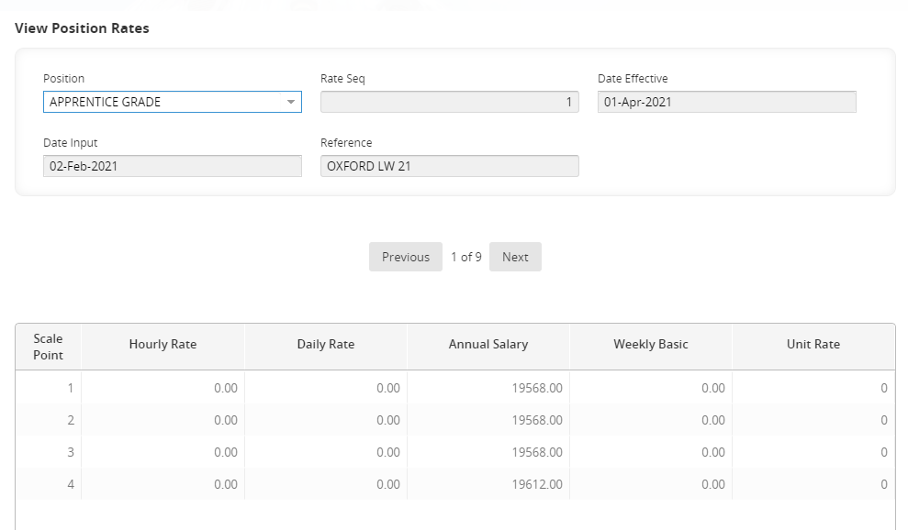

 | NB: To view a history of changes click on Next.

Viewing Scale Points

Core|Portal > Payroll Dashboard > Settings > Pay Rates > Scale Point Profile

 | Scale Points can also be viewed in People Management: Core|Portal > People Management > Data Centre > Reference Data > Pay Scale Point

  - Enter/select the Position Code you wish to view. The points will be displayed.

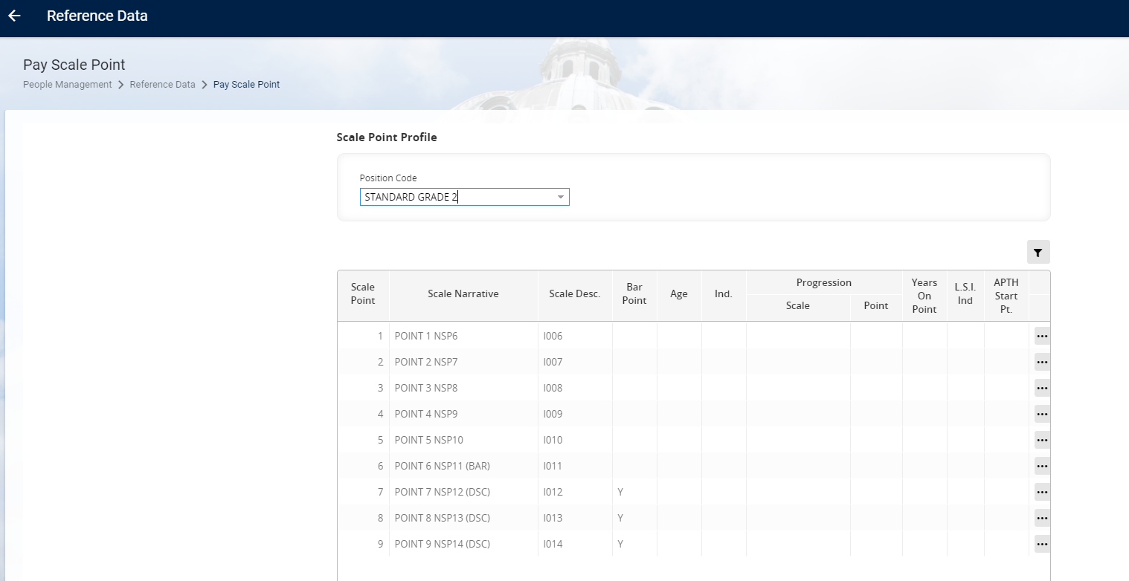

  - You can also use the advanced filter to view specific attributes, e.g. all grades with a specific point:

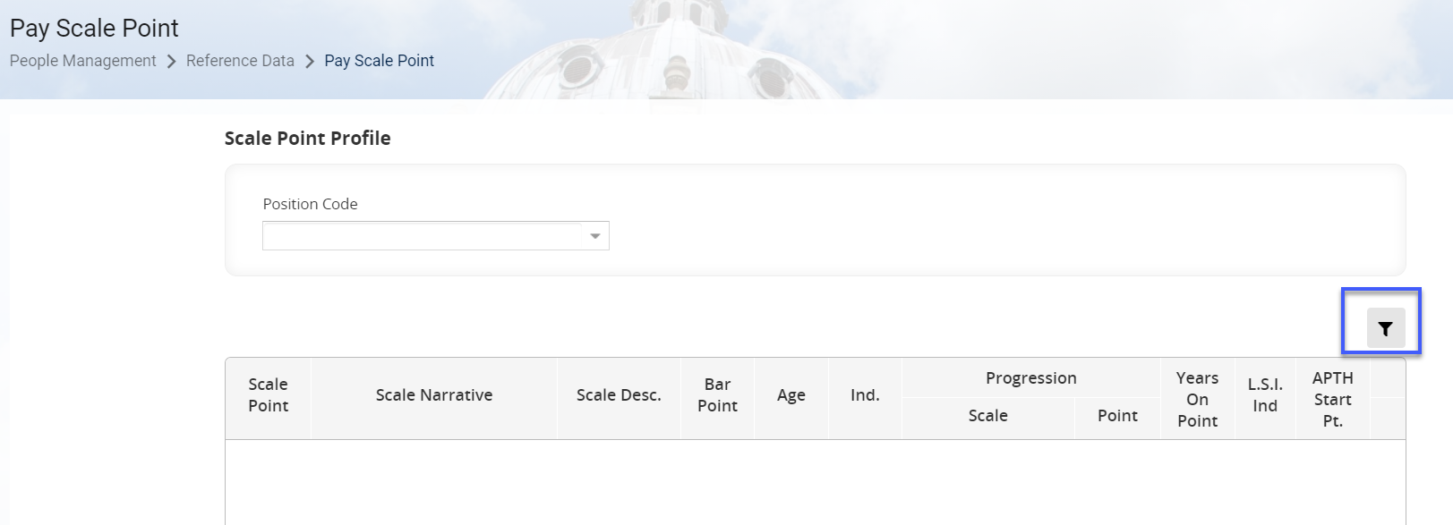

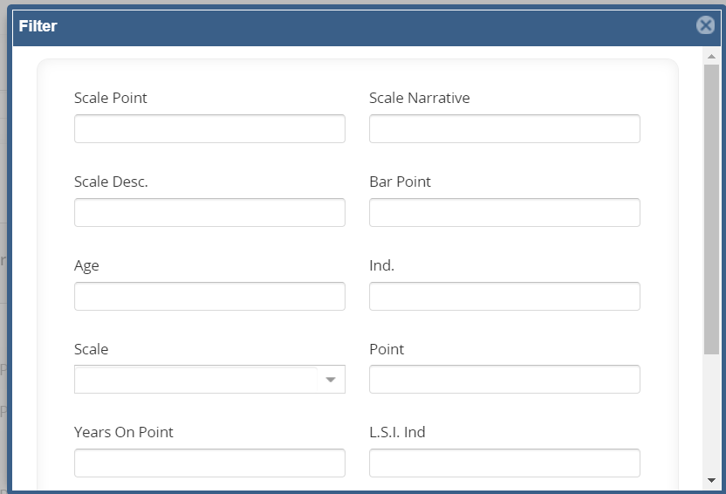

Adding a new Pay Scale (Grade)

Setting up the Pay Scale

Core|Portal > People Management > Data Centre > Reference Data > Pay Scales

    - Click on Add to insert a new row.

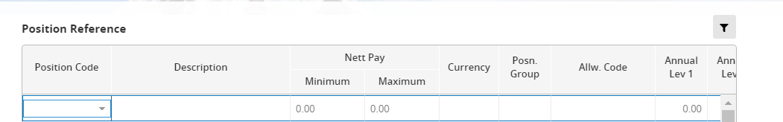

    - Enter the new Position Code and Description. The minimum and maximum values are optional.

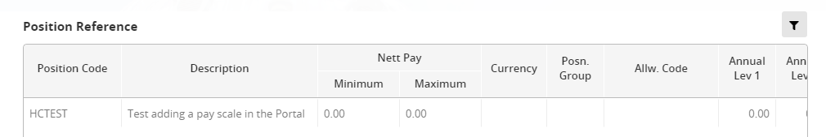

 | NB: The Description should include the grade code in brackets if the grade is to be shown on Staff Requests.

    - Scroll to the right until you can see the Active on Staff Req. column. Toggle ON if the grade should be available to select on the Staff Request.

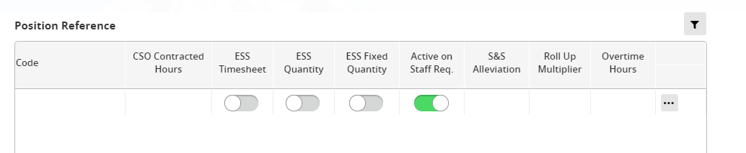

 | NB: The default toggle position is ‘ON’ unless it is a grade that is closed to new starters.

    - Click Save and exit via the breadcrumb trail.

Setting up the Scale Points

Core|Portal > People Management > Data Centre > Reference Data > Pay Scale Point

    - Enter/select the Position Code which you set up in step 1.

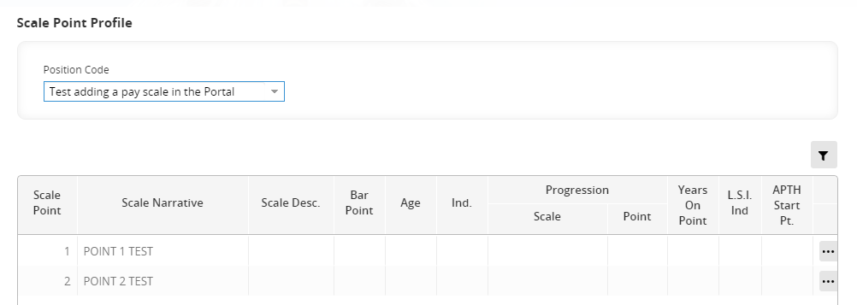

    - Click on Add to insert a new row.

Enter details as follows:
Field Name | Description
Scale Point | Starting with 1 enter ascending scale points as required
Scale Narrative | Enter a Description for each scale
Scale Desc. | Optional – tends not to be used for new grades
Bar Point | Enter Y if the scale point is not to be included in the automatic increment process. Varies for each grade.

    - Repeat for each scale point required.

    - Click Save and exit via the breadcrumb trail.

Setting up the Rates (Annual salary)

Core|Portal > People Management > Data Centre > Reference Data > Pay Scale Rates

 | Scale Points can also be viewed in People Management: Core|Portal > Payroll Dashboard > Pay Rates > Add Position Rates

    - In the Position field enter/select the Position Code you created in step 1.

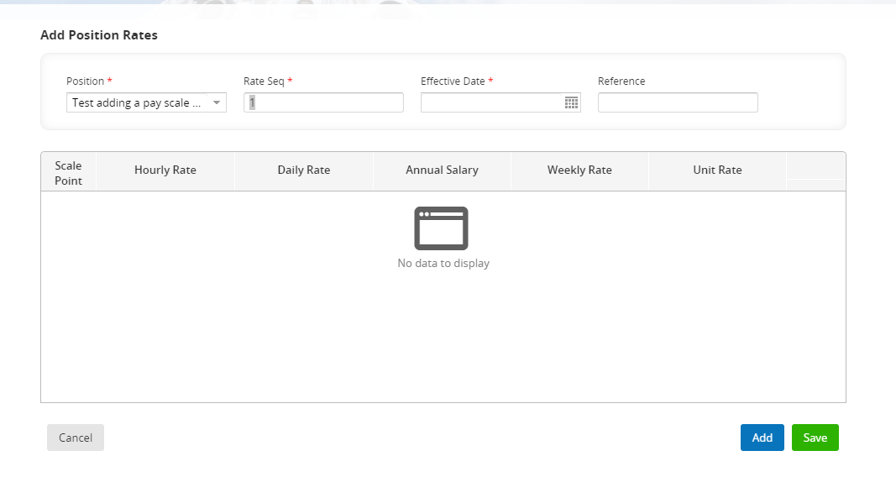

 | NB: the Rate Seq. should always be 1 for salaries.

    - Enter the Effective Date and Reference (usually agreed with Payroll) and press TAB. The points associated with the grade will automatically appear:

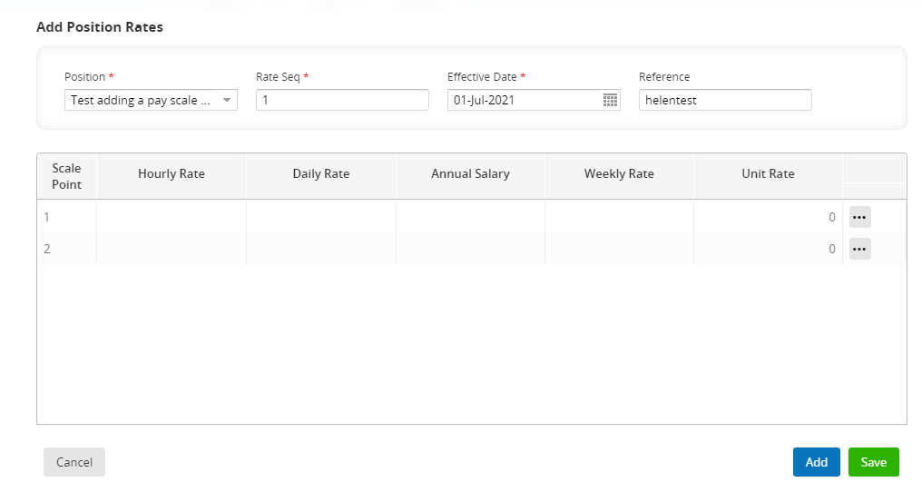

    - Enter the Annual Salary applicable for each Scale Point.

    - Click Save. Exit via the breadcrumb trail.

Assign Pension to Grade

Payroll Dashboard > Settings > UK Tax Rates > General > Maintain Statutory Pay Parameters

    - Scroll to the bottom of the page and click on the Auto Enrolment button

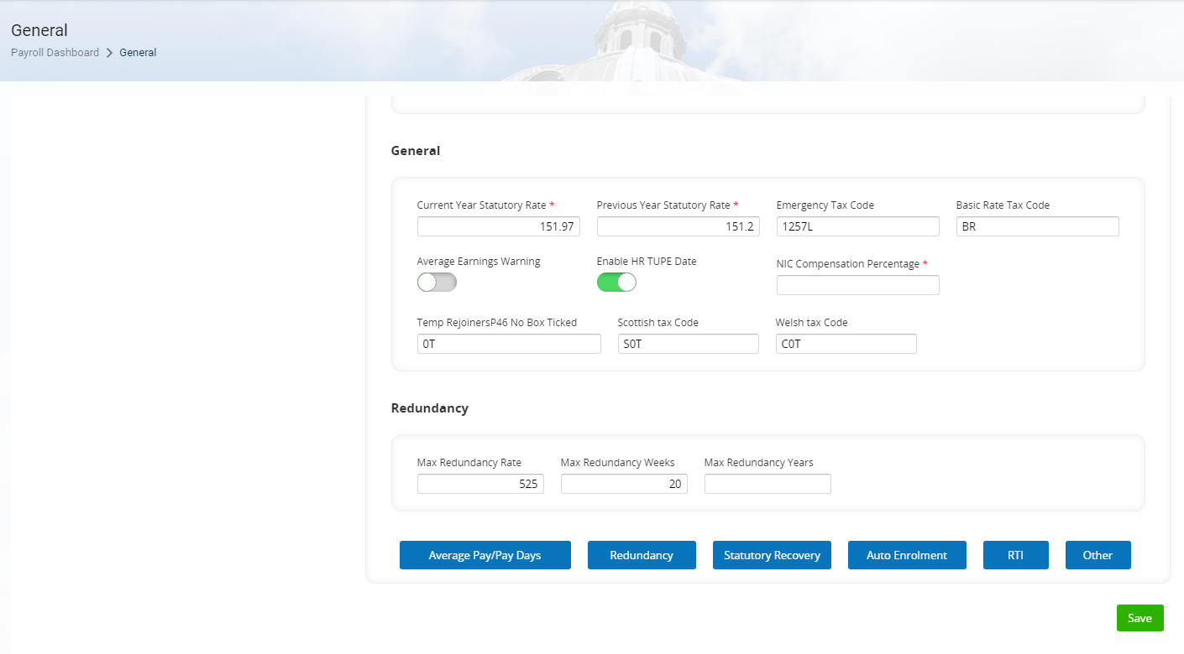

    - Under Options click on option 06 - Pension Rules

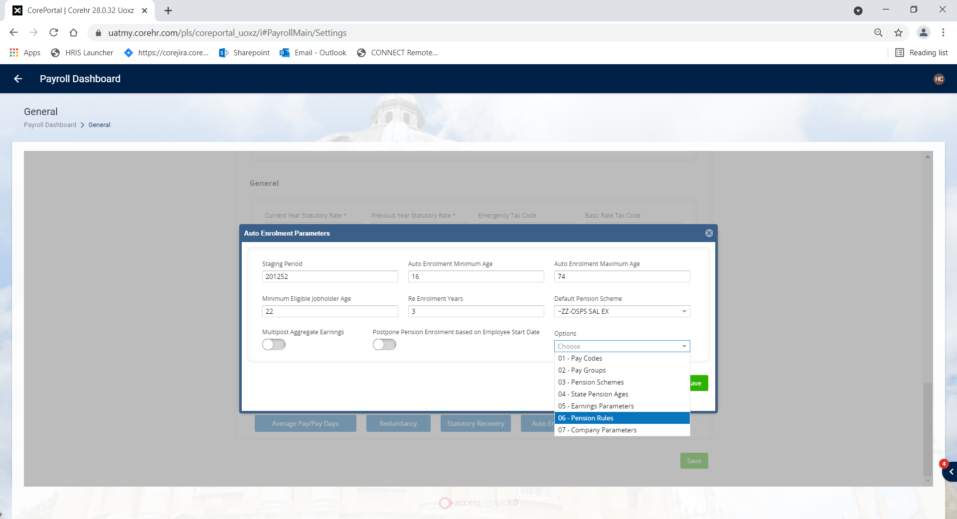

    - In the Default Pension Rules tab scroll down to find your new grade(s).

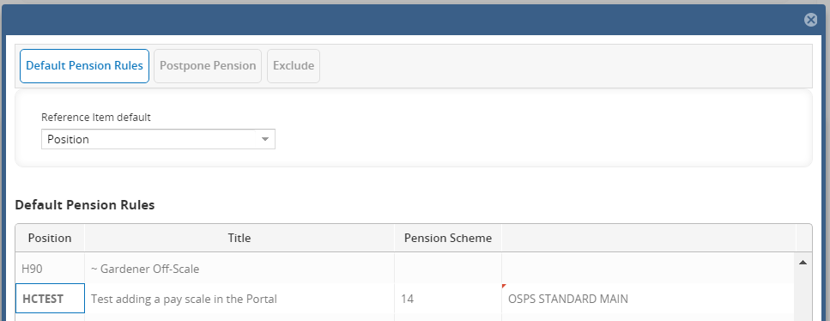

    - Click on the grade to be updated, enter the Pension Scheme number and tab to populate the description.

    - Click Save and exit via the breadcrumb trail.

Set up PR and GL output rules

Core|Portal > Payroll Dashboard > General Ledger Costing > General Rules and Settings > Maintain GL Parameters

    - In the Select Detail menu, select ER Cost Savings Control Accounts

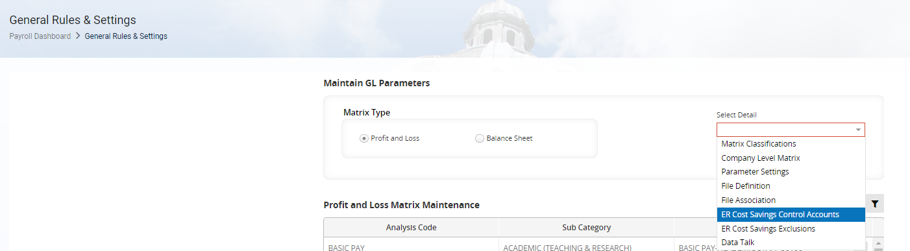

    - Select the Projects File Interface tab

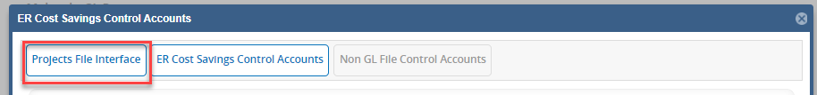

    - Ensure the Reference Item is set to Position Code then scroll down to find your grade.

 | NB: the sort order is random, so your new grade may be at the bottom of the list.

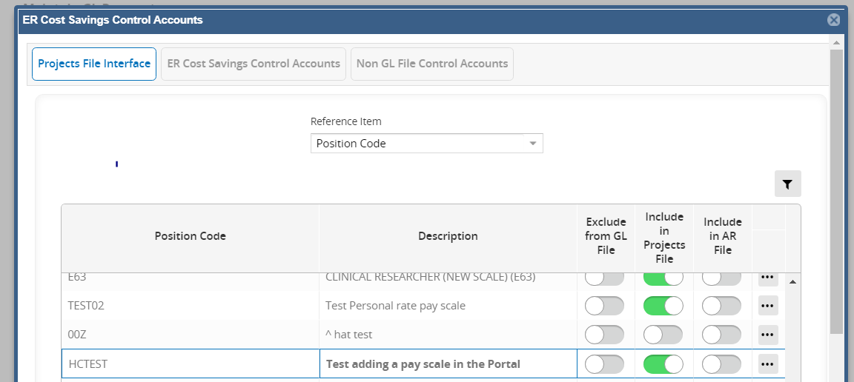

    - Click the checkbox under the Include in Projects File column (this applies for all grades).

    - Click Save then OK the confirmation message.

 | NB: The Exclude from GL file column should only be ticked if the grade needs to be masked in the GL file. This is unlikely to be required in most cases but should be confirmed before you set up the grade. More information can be found in the “Additional Background Information” section of the Grades and Rates Knowledge Article.

Editing existing Pay Scales Rates

Core|Portal > People Management > Data Centre > Reference Data > Pay Scale Rates

Updating the rates

    - Enter/select the Position Code that you are editing and press tab.

    - Enter/select the agreed Effective Date, and enter the Reference then tab. (The scale points assigned to the position will automatically appear but with no values.)

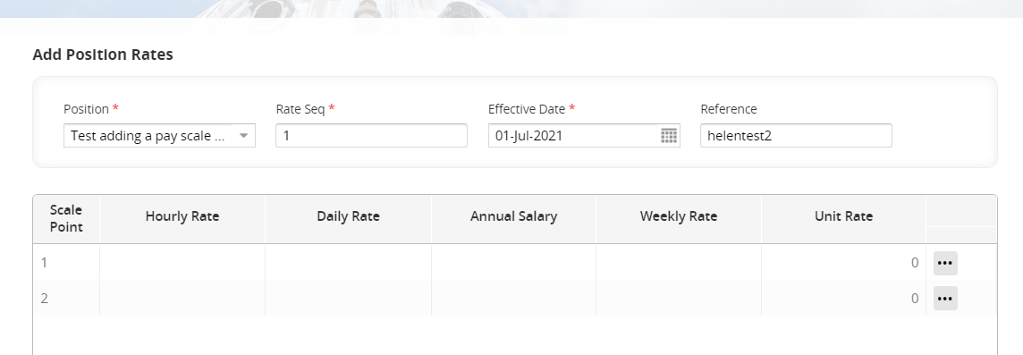

    - Enter the revised Annual Salary against each Scale Point and SAVE.

 | NB: Check whether any changes made to standard grades also need to be made to the equivalent Linacre College Grades (ZC01S to ZC10S inclusive).

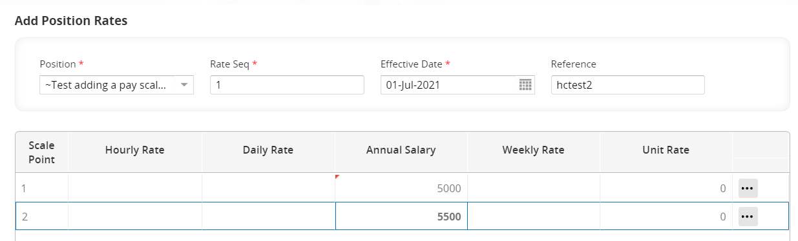

    - Click Save then OK the confirmation message.

Removing existing pay scale points

 | NB: We cannot remove scale points once they have been created. If a point is no longer required, the annual value must be set to 0.01.

    - Follow the steps in 3.1.

Adding a new pay scale point to an existing grade

Core|Portal > People Management > Data Centre > Reference Data > Pay Scale Point

    - Enter/select the Position Code for the grade you wish to add a scale point to. The existing scale points will be displayed.

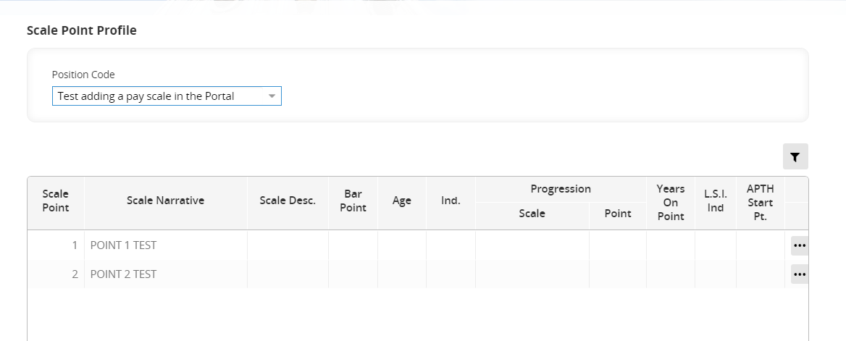

    - Click on the last scale point in the list then click Add to insert a new row.

Enter details of the new point as follows:
Field Name | Description
Scale Point | Enter the next available ascending scale point value(s) as required
Scale Narrative | Enter a Description for the new scale point
Scale Desc. | Optional – tends not to be used for new grades
Bar Point | Enter Y if the scale point is not to be included in the automatic increment process. Varies for each grade.

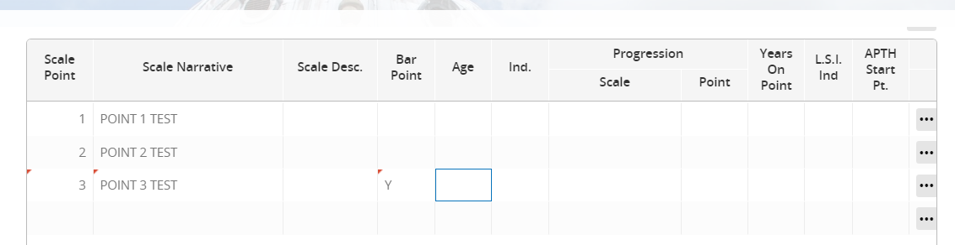

    - Click Save then OK the confirmation message.

    - Follow the steps in 3.3 to add the rates for the new point – note you will need to enter the new scale point before you can enter the rate.

Removing an existing Grade

You cannot delete a grade from the system but you can either close the grade to new employees or close the grade completely.

Core|Portal > People Management > Data Centre > Reference Data > Pay Scales

    - Scroll down or use the advanced filter to find the relevant Pay Scale

    - Update the Description with the prefix which denotes the state of the grade.

- ^ denotes an open grade with current employees but closed to new appointments

- ~ denotes a closed grade with no current employees

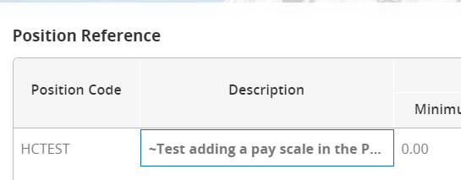

    - Click Save then OK the confirmation message.

    - Exit via the breadcrumb trail.

